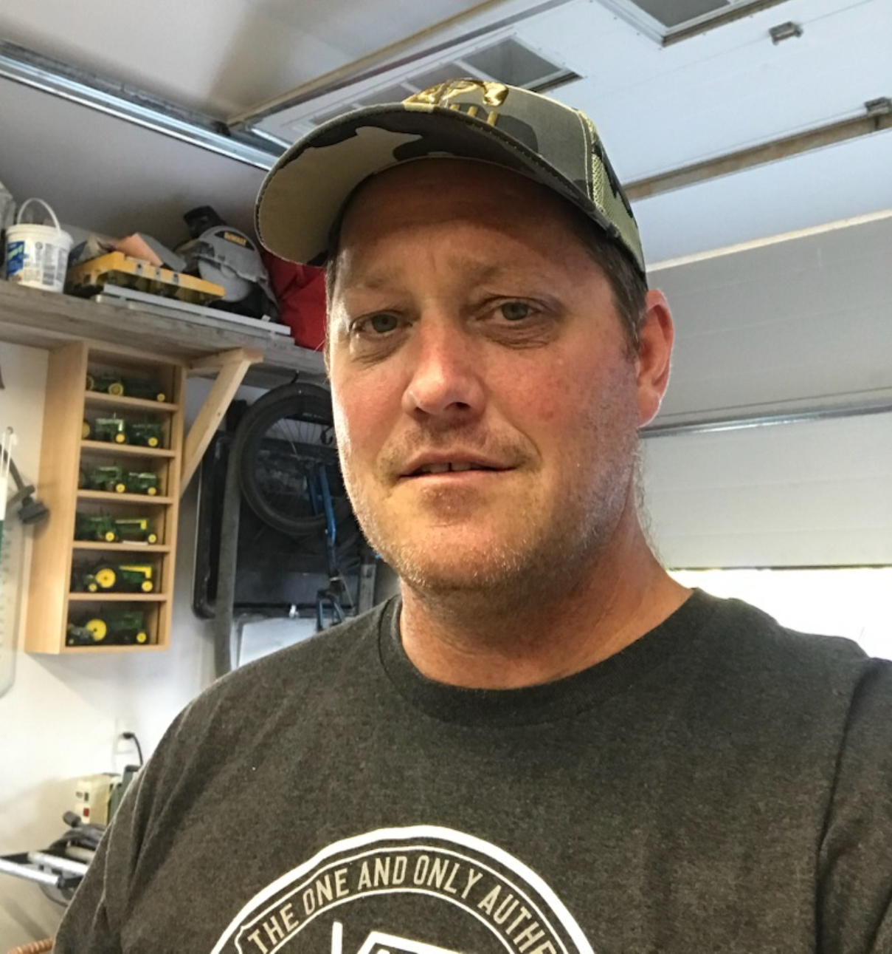  Ken Wright  for maintenance shop steward  It’s all about trust. | Honesty  Integrity  Trusted  Valued  Respected  Solidarity  I would like the opportunity to fairly represent all of our members

